NAAN MUDHALVAN

TITLE : LOGO CREATION

USER NAME : B2F8931465B7584B39544A589B539B36

1.Open canva 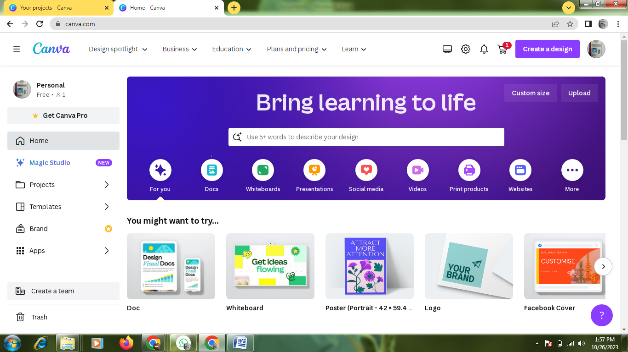

2.select a template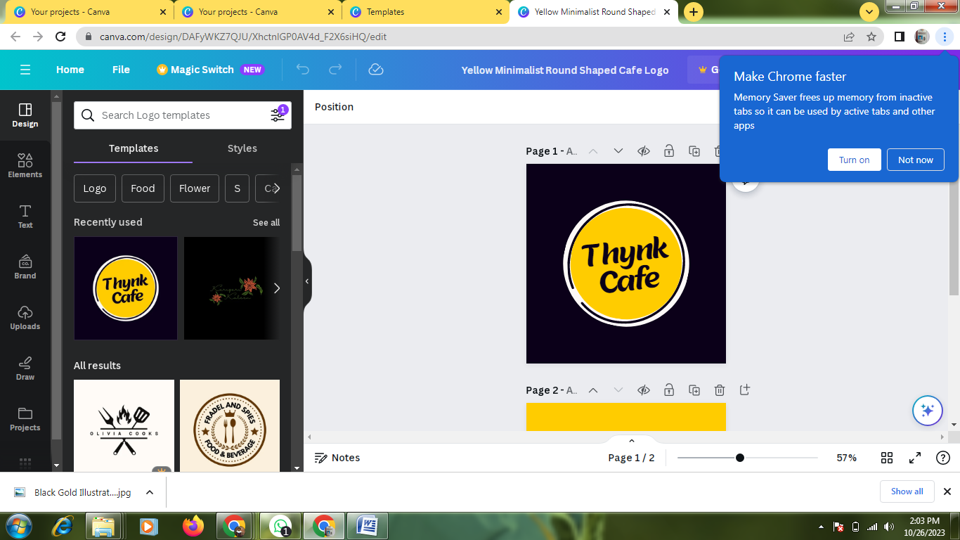

3.Edit a details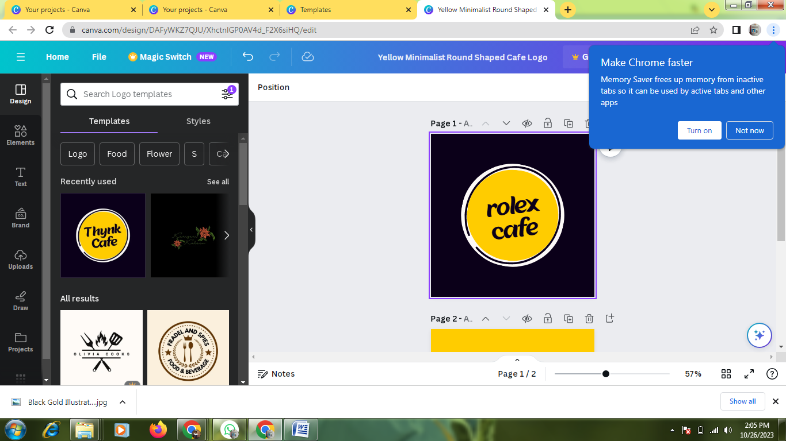

4.Pdf covert